# The Dataset

The dataset contains 10 columns and 1,074 rows, representing unicorn companies (startups valued at $1 billion or more). Here's a breakdown of the columns:

1. Company: Name of the unicorn company.
2. Valuation: The company’s valuation in USD (as a string initially).
3. Date Joined: The date the company achieved unicorn status.
4. Industry: The sector or field the company operates in.
5. City: The city where the company is headquartered.
6. Country/Region: The country or region of the company’s headquarters.
7. Continent: The continent the company belongs to.
8. Year Founded: The year the company was established (stored as an integer).
9. Funding: The total funding raised by the company (as a string initially).
10. Select Investors: Key investors in the company.

# Application of DIKW

The DIKW framework helps us systematically process the unicorn dataset to generate actionable insights. We have conducted a detailed Exploratory Data Analysis and generated the required visuals. Now we will use this structured approach to turning raw data into meaningful insights for stakeholders, helping both startups and investors strategize effectively.

**For this specific EDA report, we would apply the DIKW framework. The application of DIKW would be as follows:**

1. **Data**
2. **Analysis = Information + Knowledge**
3. **Recommendations = Wise decisions based on the proper Analysis**

## Insight 1:

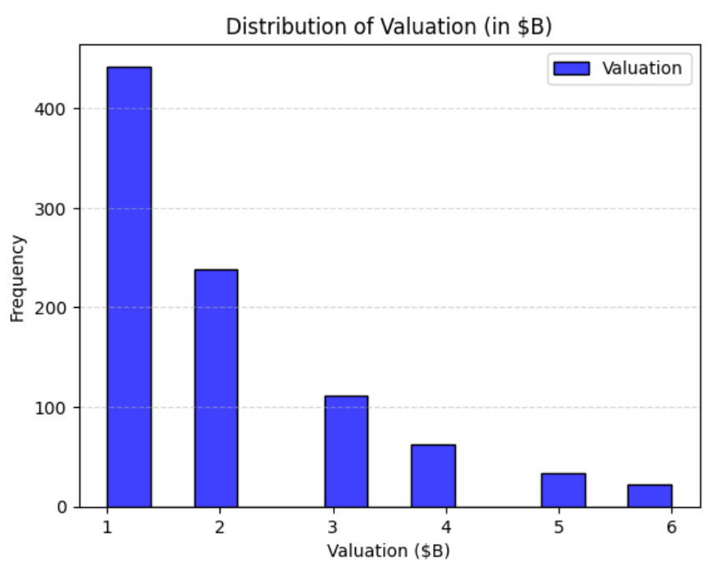

**1. Data**:

* This chart shows the valuation of unicorn companies (in billions of USD).
* Most valuations are grouped around $1 billion, and very few are higher.

**2. Information**:

* Most unicorns are just above the $1 billion mark.
* The number of companies decreases as valuations increase, with very few exceeding $4 billion.

**3. Knowledge**:

* Most unicorns have just crossed the $1 billion threshold, showing they are relatively new or smaller in scale.
* Only a few companies are valued much higher, which likely includes globally recognized names.

**4. Wisdom**:

* To help startups grow, focus on what helps companies move beyond the $1 billion mark.
* We could look deeper into factors like industries, countries, or investors to find what drives higher valuations.

## Insight 2:

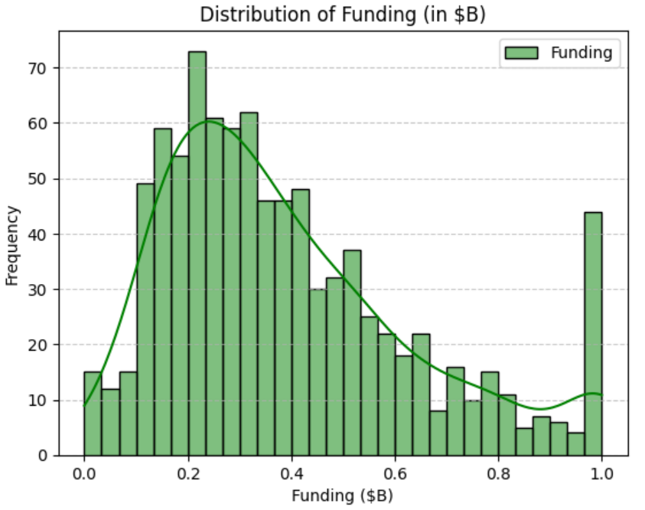

**1. Data**:

* This chart shows the distribution of total funding (in billions of USD) for unicorn companies.
* The data has been cleaned and standardized for analysis.

**2. Analysis:**

* Most unicorns tend to raise funding between $0.1B and $0.5B, and the highest number of companies falls around $0.2B.
* The number of companies drops sharply after $0.5B, showing fewer unicorns with higher funding levels.
* There’s a noticeable jump at $1B, which might be due to data rounding or companies grouping around that mark.
* Overall, most unicorns stick to moderate funding levels relative to their valuations.
* That spike at $1B could mean a group of companies raised exceptionally high amounts or it could need a closer look to confirm why it stands out.

**3. Recommendations:**

* Startups looking to hit unicorn status should aim for funding rounds in the range of $0.1B to $0.5B, as that’s where most successful companies seem to fall.
* A deeper dive into companies raising over $0.5B might uncover patterns or strategies that lead to higher valuations or faster growth.

## Insight 3:

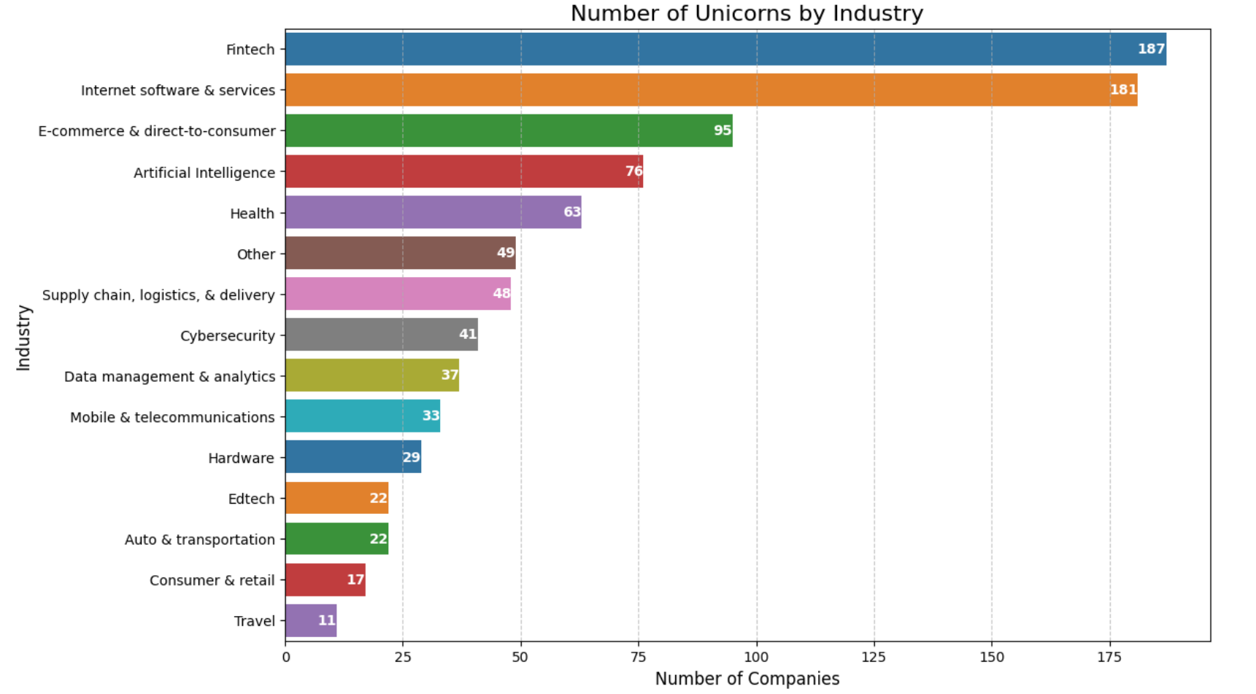

**1. Data**:

* This chart shows the number of unicorn companies in different industries.
* The dataset includes industries like Fintech, Internet Software & Services, E-commerce, and others.

**2. Analysis:**

* Fintech is leading the way with 187 unicorns, and Internet Software & Services is right behind with 181.
* E-commerce (95) and Artificial Intelligence (76) also have a strong presence, showing how important they’re becoming in the market.
* On the other hand, industries like Travel and Consumer & Retail have far fewer unicorns, falling behind compared to others.
* Fintech and Internet services dominate because there’s such a big demand for innovation in financial tools and digital platforms.
* Sectors like AI and Health are picking up speed, while older industries like Travel and Retail seem to be struggling to keep up with how fast things are changing.

**3. Recommendations:**

* Investors should focus on Fintech, Software, and AI for better growth opportunities since these industries have the most unicorns.
* Giving more support to emerging sectors like AI and Health could help them grow faster and improve their representation in the market.
* For industries like Travel, innovative solutions might be the key to helping them catch up and compete better.

## Insight 4:

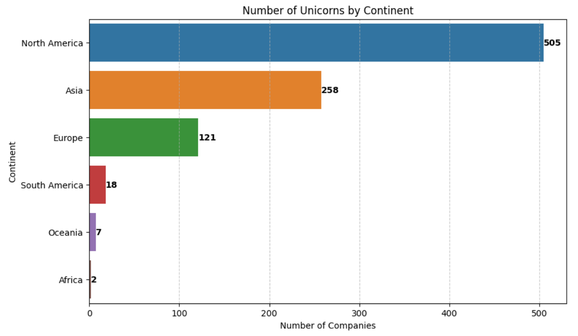

**1. Data**:

* This chart displays the number of unicorn companies distributed across continents.

**2. Analysis:**

* North America is way ahead with 505 unicorns, almost double the number in Asia (258), showing how dominant it is in the unicorn ecosystem. This is likely because of its strong venture capital networks, established tech hubs like Silicon Valley, and a business-friendly environment.
* Asia is also a big player, thanks to fast-growing economies like China and India that push innovation and digital transformation forward.
* Europe has 121 unicorns, which is fewer than North America and Asia, but it’s still doing well in areas like Fintech and Software.
* Other regions like South America, Oceania, and Africa are far behind, with Africa having only 2 unicorns. This shows that these areas face challenges in building strong startup ecosystems.

**3. Recommendations:**

* Startups in regions like South America, Oceania, and Africa need better access to funding and ecosystem support to boost their unicorn numbers.
* Policymakers in Europe should work on encouraging innovation and improving venture funding so the region can better compete with North America and Asia.

## Insight 5:

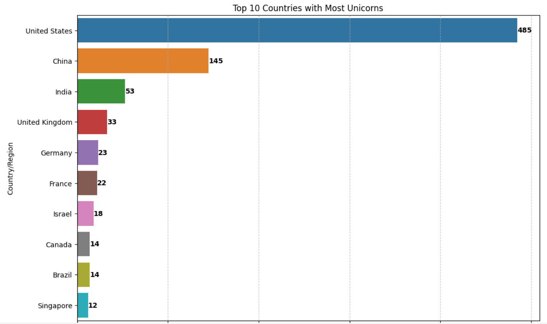

**1. Data**:

* This chart shows the top 10 countries with the highest number of unicorn companies.

**2. Analysis:**

* The United States is leading with 485 unicorns, which reflects its strong startup culture, advanced funding ecosystem, and a focus on technological innovation.
* China comes next with 145 unicorns, followed by India with 53, making them the key players in Asia. Their growth is driven by large consumer markets and rapid digitalization.
* In Europe, countries like the United Kingdom (33), Germany (23), and France (22) have moderate numbers, showing smaller but steadily growing startup ecosystems compared to the U.S. and China.
* Emerging players like Israel (18), Canada (14), Brazil (14), and Singapore (12) show potential for future growth if given more investment and ecosystem support.

**3. Recommendations:**

* Countries like Brazil and Singapore, which have fewer unicorns, could benefit from focused investment and policy support to encourage innovation.
* Emerging markets in Europe and Asia can learn from the strategies of U.S. and China to scale their ecosystems and attract more unicorns.
* Investors should keep an eye on smaller but promising markets, such as Brazil and Singapore, as they show growth potential.

## Insight 6:

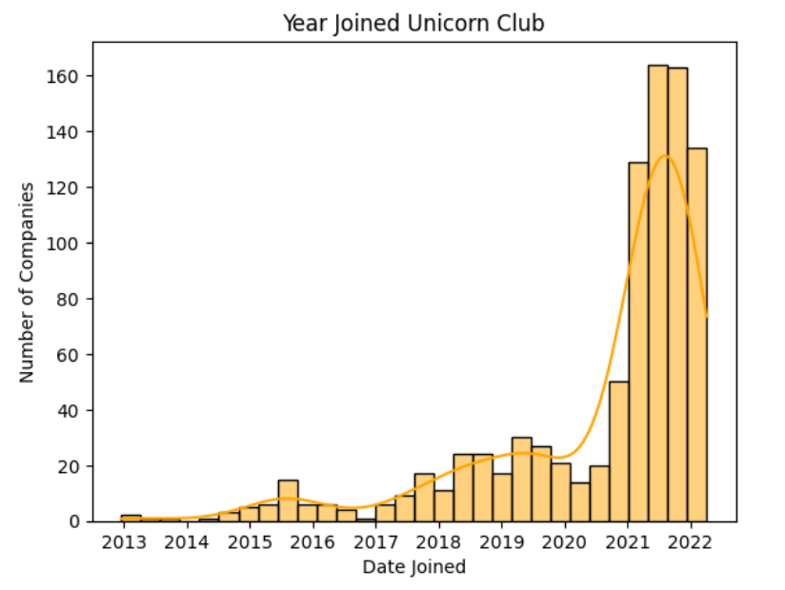

**1. Data**:

* This chart shows when companies joined the unicorn club, ranging from 2013 to 2022.

**2. Analysis:**

* The number of unicorns joining the club stayed low until 2018, but things picked up sharply from 2019, with the peak happening in 2021, which had the highest number of unicorns.
* This boom after 2019 was likely driven by increased investment activity, pandemic-driven digital adoption, and more focus on technology startups.
* There’s a small dip in 2022, which could be because the year’s data isn’t complete yet or due to market corrections or saturation in certain sectors.

**3. Recommendations:**

* The sharp rise in unicorns after 2019 shows how economic and tech shifts can boost startup success.
* Future studies could look into how the pandemic impacted growth in industries like Fintech, AI, or E-commerce.
* Investors might want to explore emerging sectors now, as some industries could slow down after 2022.

## Insight 7:

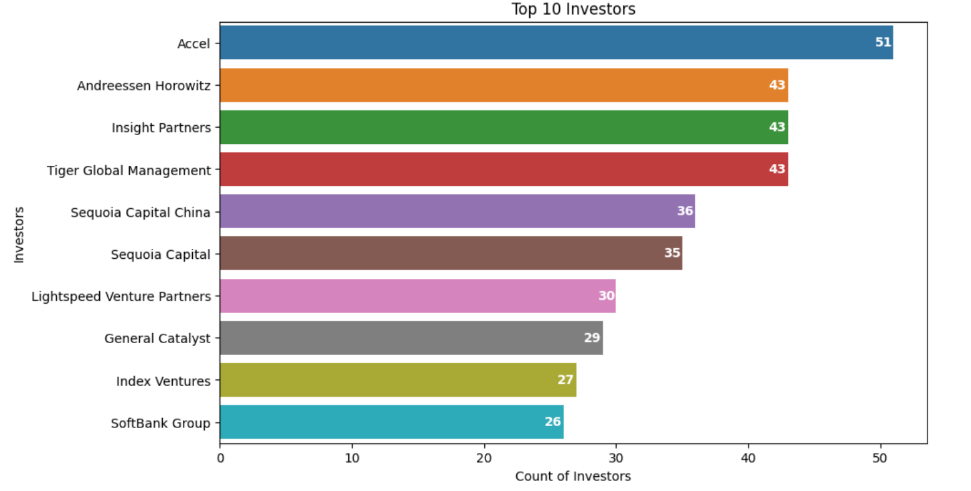

**1. Data**:

* This chart highlights the top 10 investors by the number of unicorn companies they have backed.

**2. Analysis:**

* Accel is leading the pack with 51 investments in unicorn companies, showing its strong ability to consistently spot and fund startups with high potential.
* Andreessen Horowitz, Insight Partners, and Tiger Global Management are close behind, each tied with 43 unicorn investments.
* Big players like Sequoia Capital China (36) and Sequoia Capital (35) stand out for their global reach and smart strategies across different markets.
* Other key names include Lightspeed Venture Partners (30), SoftBank Group, General Catalyst, and Index Ventures, with investments ranging from 26 to 29 unicorns.
* SoftBank is especially notable for backing startups that need significant capital to scale quickly and expand into global markets.

**3. Recommendations:**

* Startups that want to hit unicorn status should aim for investors with strong track records, like Accel, Tiger Global, and Sequoia.
* Emerging investors could learn from the strategies of these top firms to improve their portfolios and boost their success rates.
* Policymakers and ecosystem builders can use this information to encourage global collaboration with these leading investors, helping startups thrive on a bigger scale.

## Insight 8:

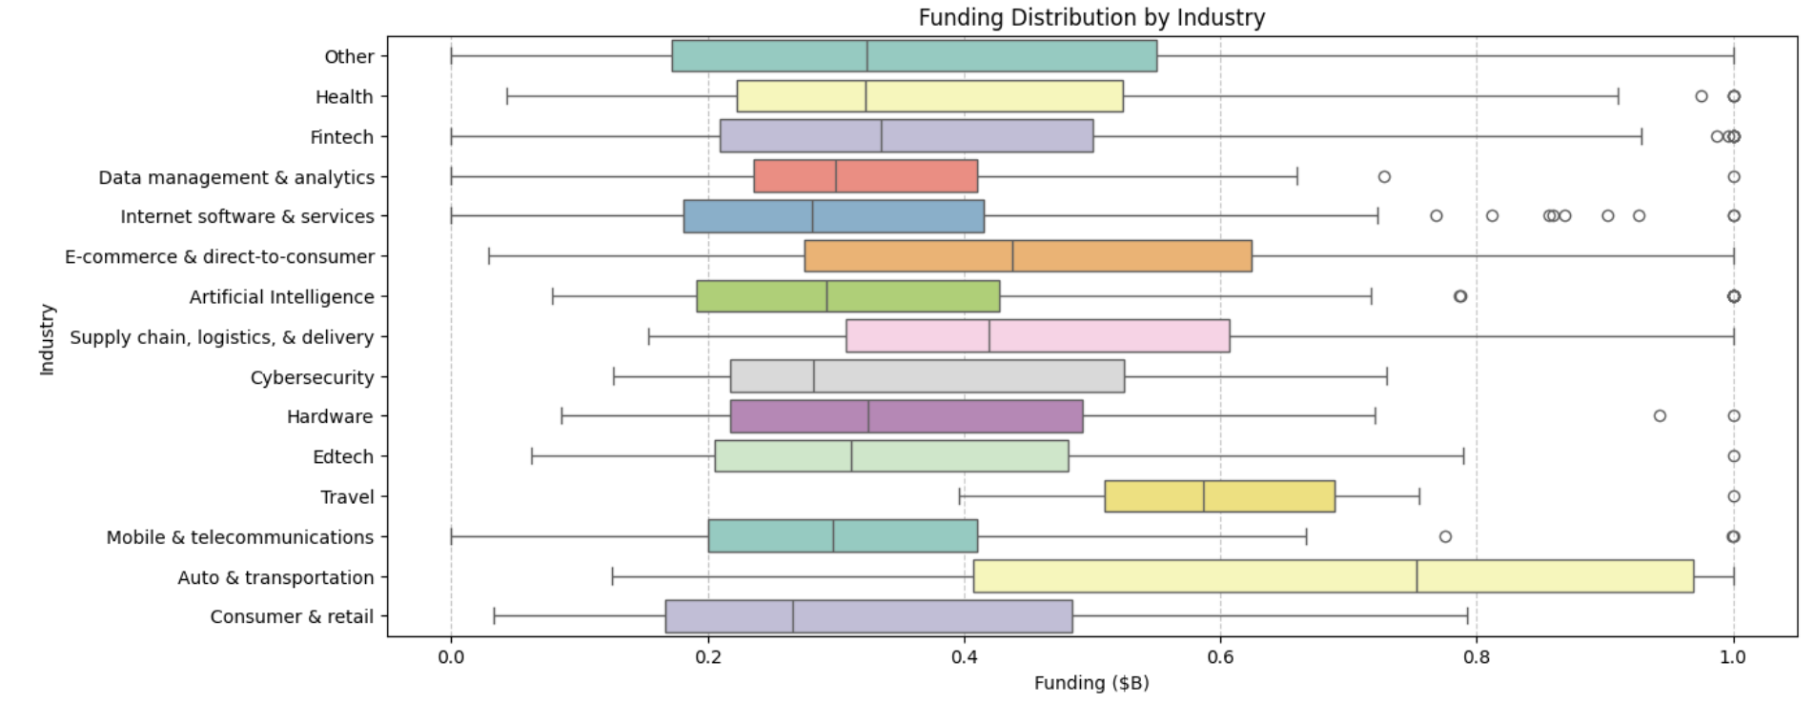

**1. Data**:

* This boxplot shows the distribution of total funding (in billions of USD) across various industries.

**2. Analysis:**

* E-commerce & Direct-to-Consumer has the widest funding range, showing a lot of variation in the amount of capital companies raise. This is probably because of the different business models and funding needs within the sector.
* Fintech, Internet Software & Services, and Artificial Intelligence also have high funding levels, but their funding ranges are more consistent, which shows steady and reliable investor interest.
* Travel and Consumer & Retail have higher median funding, likely because they need substantial upfront capital for scaling and infrastructure. These sectors, however, have fewer outliers compared to others.
* Health and Edtech tend to have lower median funding, possibly because they’re smaller, more niche markets. That said, some companies in these sectors still manage to attract significant investments.
* Overall, E-commerce and Fintech dominate funding trends, reflecting their large market potential and strong appeal to investors, while the differences in funding highlight diverse growth strategies across industries.

**3. Recommendations:**

* Investors could focus on industries with high funding variability, like E-commerce, to explore diversification opportunities, while sectors with more stable funding trends, like Health, might be a better fit for risk-averse strategies.
* Policymakers and ecosystem builders should pay attention to low-funding industries like Edtech and work on creating opportunities to help them grow and stay competitive.

## Insight 9:

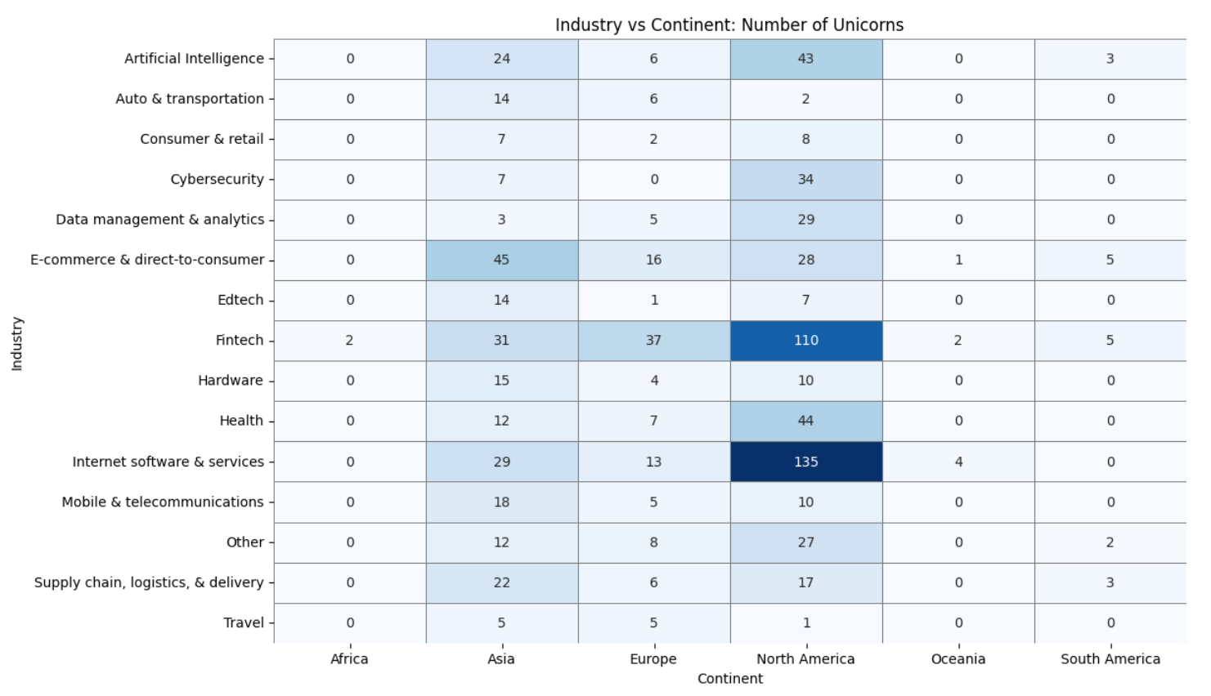

**1. Data**:

* This matrix shows the number of unicorn companies in different industries across continents.

**2. Analysis:**

* North America leads in most industries, with Fintech (110) and Internet Software & Services (135) at the top. This dominance comes from its mature startup ecosystem, strong venture capital access, and innovation hubs like Silicon Valley.
* Asia is performing well in E-commerce & Direct-to-Consumer (45) and has strong numbers in Artificial Intelligence (24) and Fintech (31). This success is driven by large consumer markets and the rapid digitalization of economies like China and India.
* Europe has fewer unicorns overall but shows good activity in Internet Software & Services (13) and Health (7), which highlights its diversification across industries.
* South America, Africa, and Oceania have minimal contributions, reflecting challenges like limited funding opportunities and smaller market sizes.
* These emerging regions could grow their unicorn presence with targeted investments and better policy support.

**3. Recommendations:**

* South America and Africa need focused investment and ecosystem development to build more unicorns.
* Asia’s strength in E-commerce and AI shows potential for future innovation and expansion in these areas.
* Policymakers and investors in Europe should concentrate on niche industries like Health and AI to boost their competitive edge globally.

## Insight 10:

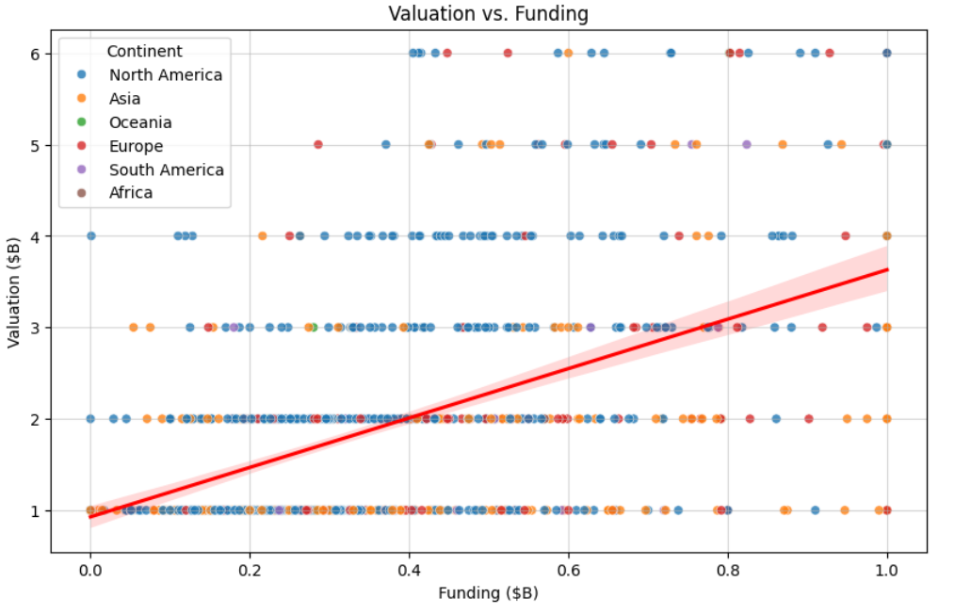

**1. Data**:

* This scatter plot shows the relationship between funding (in billions of USD) and valuation for unicorn companies, with points colored by continent.
* A red trendline represents the general relationship between funding and valuation.

**2. Analysis:**

* The plot shows a positive correlation between funding and valuation—companies with higher funding generally tend to have higher valuations.
* North America and Asia dominate in both funding and valuation, with many companies clustering near the $1B valuation mark, which is the unicorn threshold.
* There are a few outliers with exceptionally high valuations and funding levels, mostly coming from North America and Asia.
* Some companies manage to achieve high valuations with relatively low funding, likely because of innovative business models or efficient operations.
* The dominance of North America and Asia reflects their strong funding ecosystems and fast-growing markets, while the outliers show that unique strategies can also drive unicorn success without heavy funding.

**3. Recommendations:**

* Startups aiming for unicorn status should focus on balancing their funding needs with efficient resource management to get the best valuation.
* Investors should look at companies with high valuations but lower funding, as these might have scalable and innovative business models.
* Policymakers in regions with fewer unicorns can work on strengthening funding ecosystems to help more startups close the gap between funding and valuation.